**Steps to connect to MXDM IP-10.0.1.192**

1. Configuration to connect to DB Server for IP –10.0.1.192.

Enter host name as shown below.

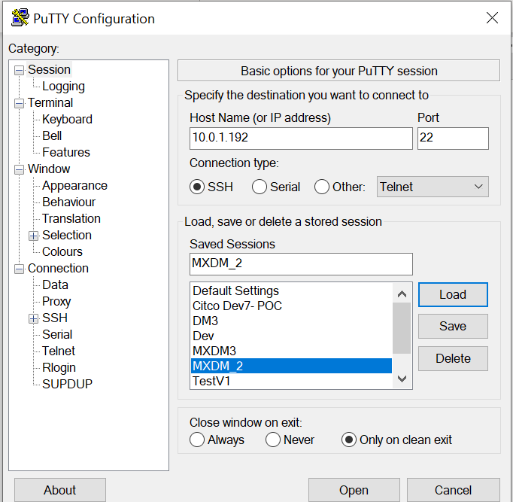

1. Add below ppk file under credentials 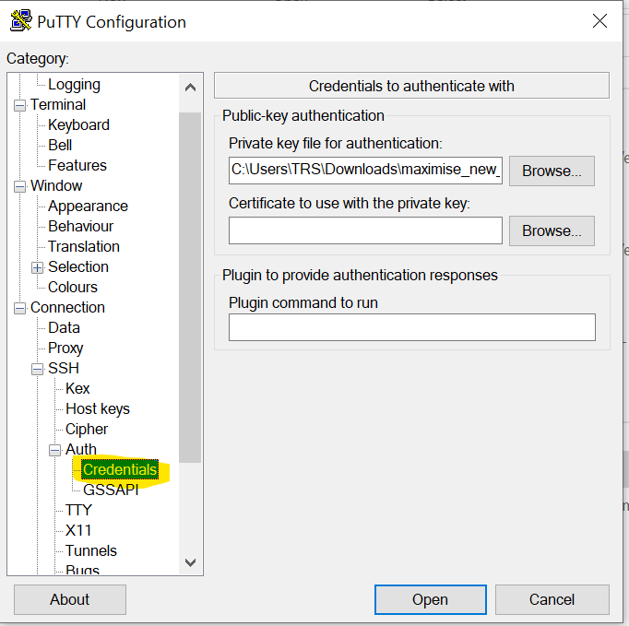



1. Save it and open the session

*Note: Should be connected to V1 ERP OCI JUMP server first only then we can connect to above session*